**DEPLOYING A WEB PAGE USING 3 PUBLIC CLOUDS**

**CLOUD COMPUTING LAB-1 Assignment**

**MAIN OBJECTIVE:**

**Task-1:** Getting access to at least 3 public clouds.

**Task-2:** Steps to deploy a simple web page on the cloud.

**Task-3:** Showing the execution of the web page from the local web browser.

**Task-4:** Describe 1) lessons learnt, 2) fun/difficult parts, 3) comparisons between GENI and CloudLab.

**1) Microsoft Azure:**

1) Created account in Microsoft azure and created virtual machine with ubuntu OS.

Enabling SSH, HTTP ports for the VM instance.

Starting the VM and connecting to the VM using putty (ssh port – 22)

Executed following commands:

Sudo apt-get install update

Downloading apache: Sudo apt-get install apache2

Creating basic html page and storing it in /var/www/html/CC.html

Starting apache port ( httpd daemon) using command sudo apachectl start

Sending HTTP request to the public IP assigned to the Azure VM.

IP/CC.html loads the web content on the client web browser.

Screenshots:

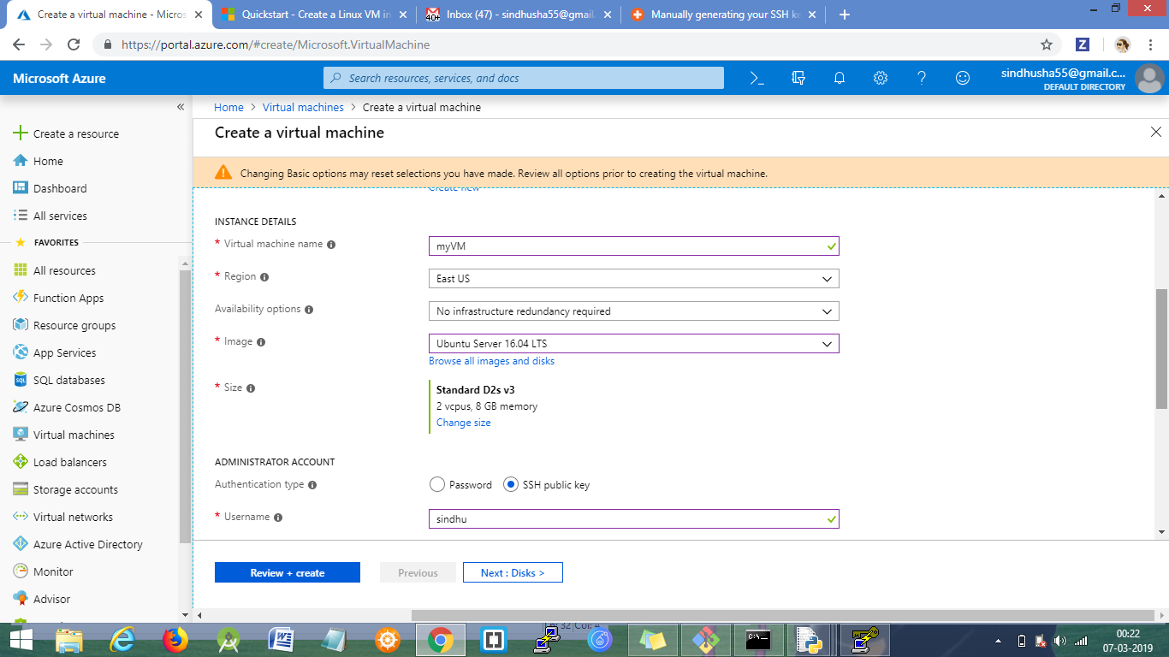

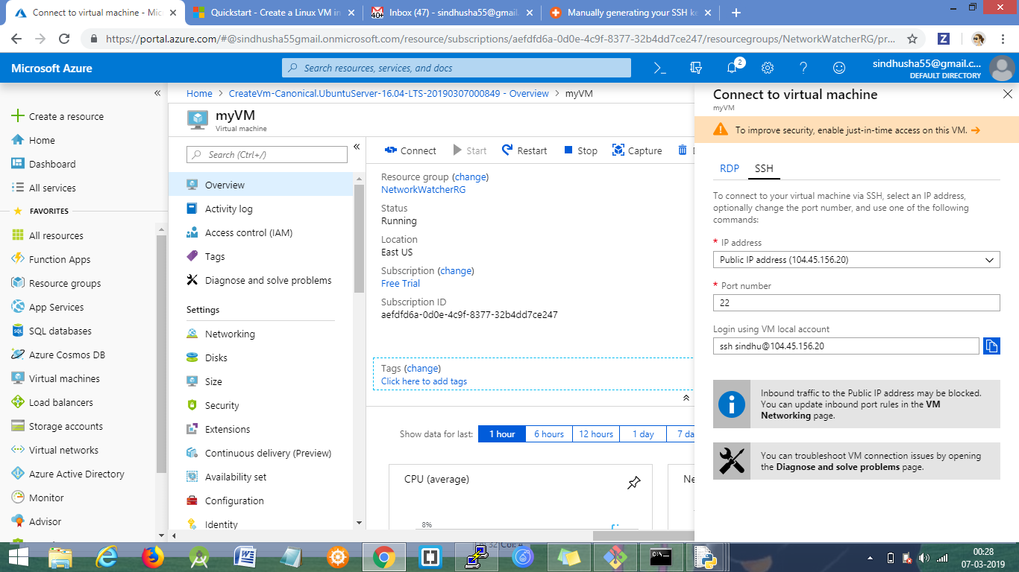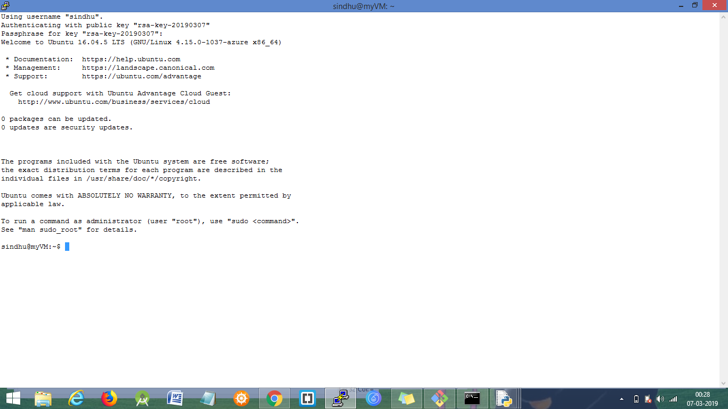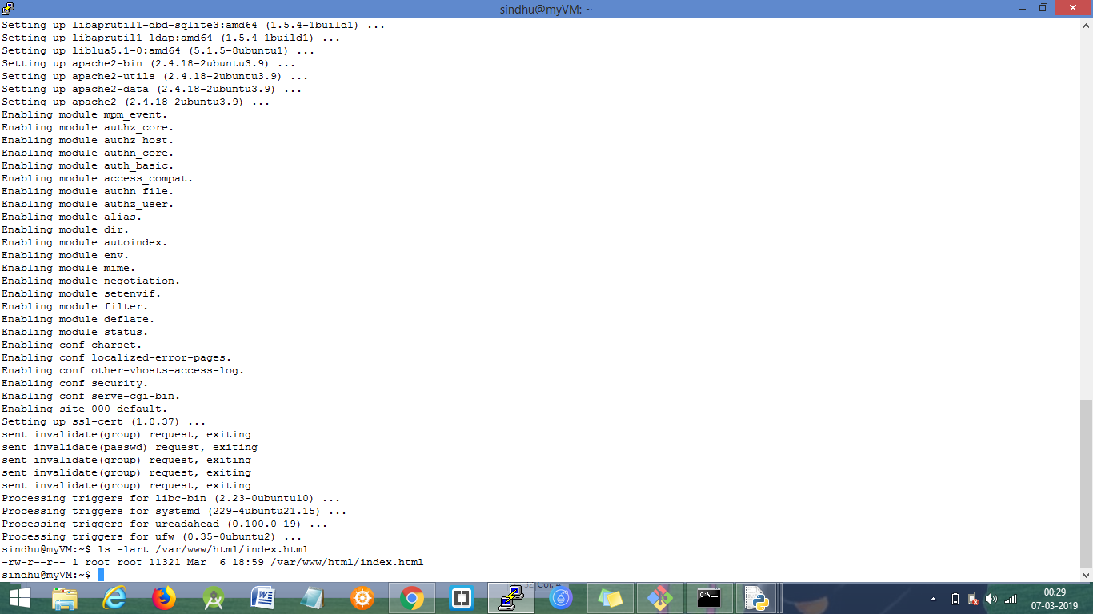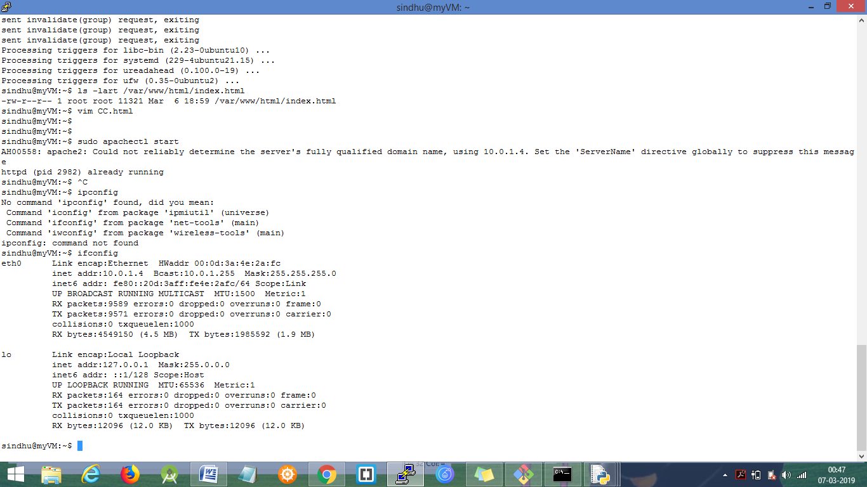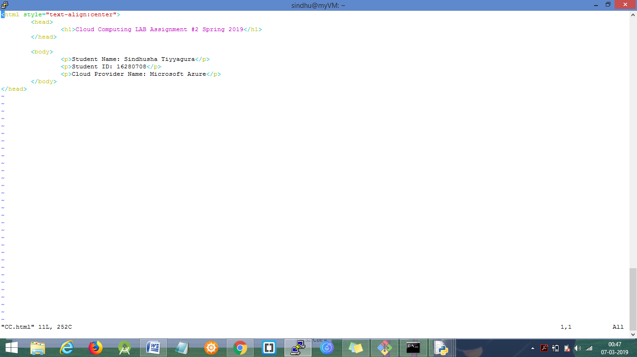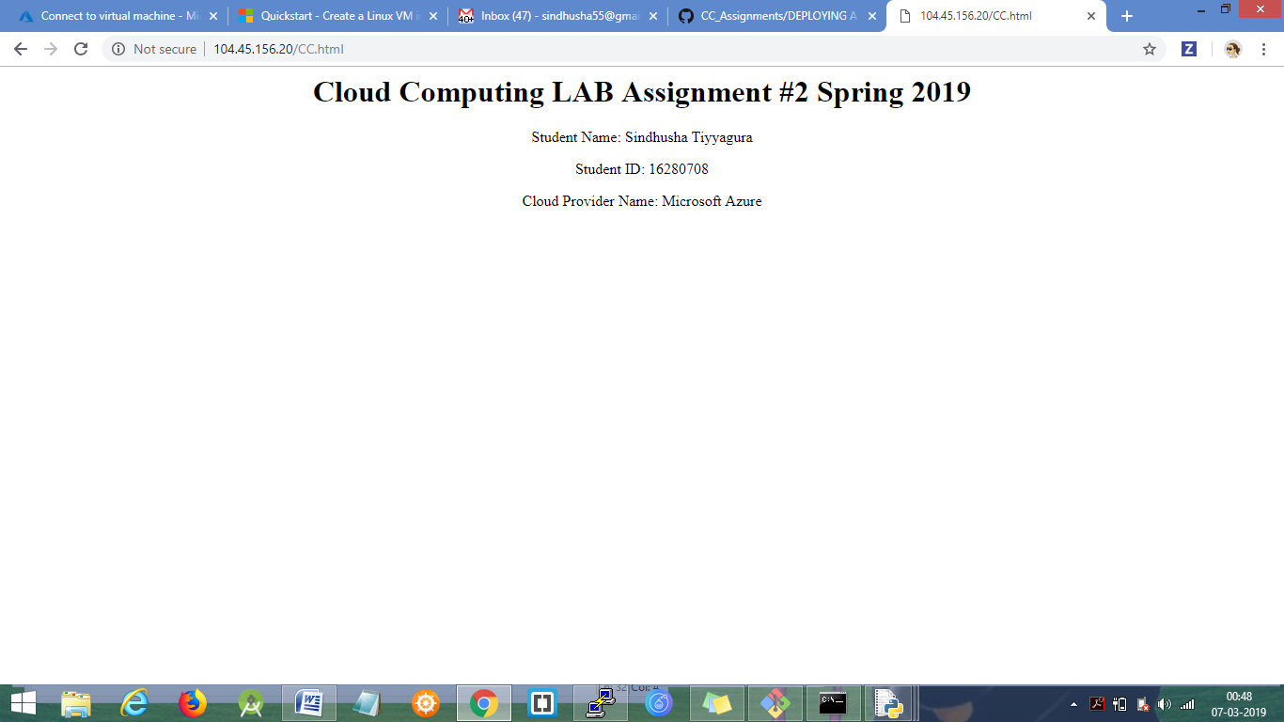

**2) Google Cloud Platform (GCP):**

Created account in Google Cloud platform using free credit and created virtual machine with ubuntu OS.

Enabling SSH, HTTP ports for the VM instance.

Starting the VM and then click on the SSH hyperlink which open a new terminal connecting to the VM.

Executed following commands:

Sudo apt-get install update

Downloading apache: Sudo apt-get install apache2

Creating basic html page and storing it in /var/www/html/CC.html

Starting apache port ( httpd daemon) using command sudo apachectl start

Sending HTTP request to the public IP assigned by the google cloud platform ( clicking on the link specified by the GCP VM – external PUBLIC IP link).

IPv4-address/CC.html loads the web content on the client web browser.

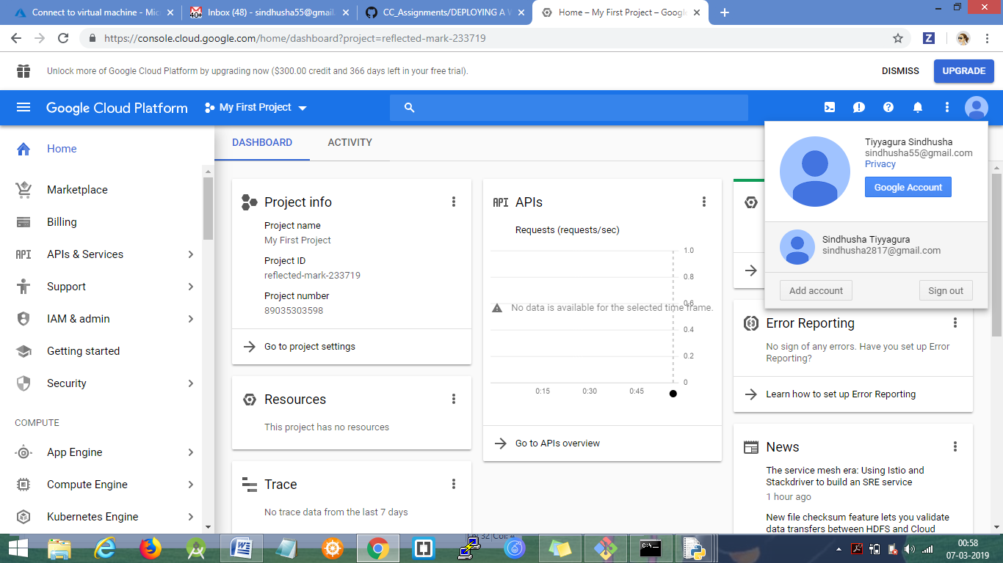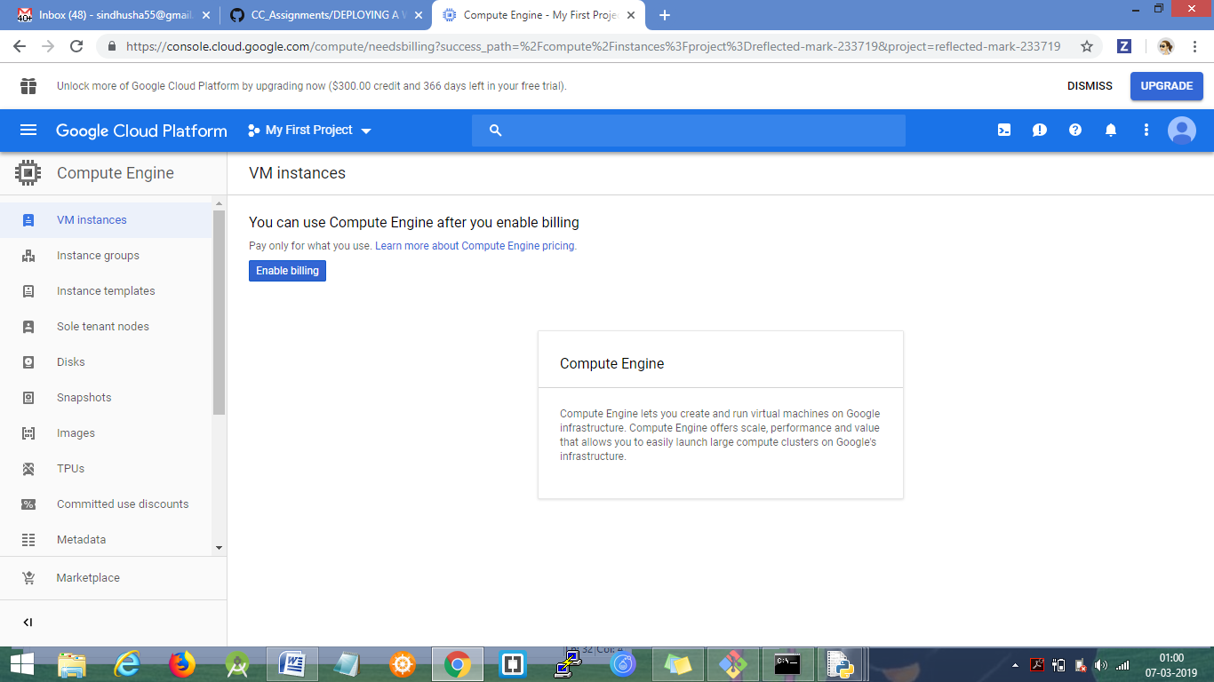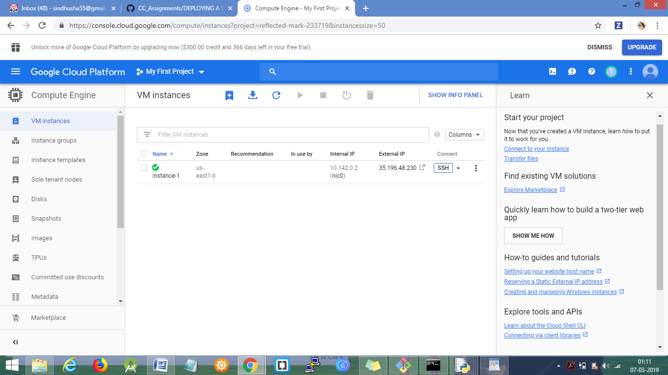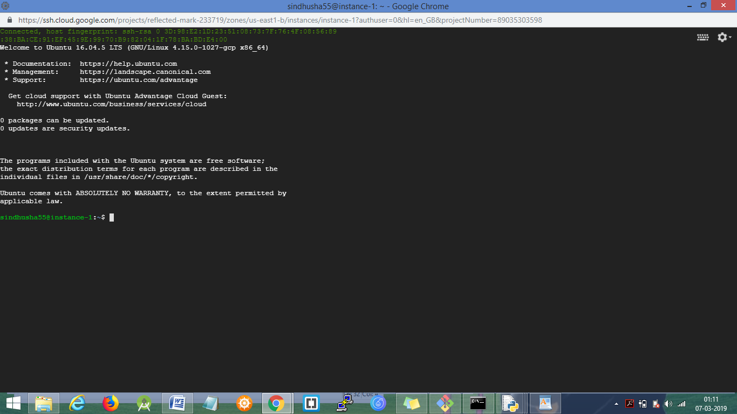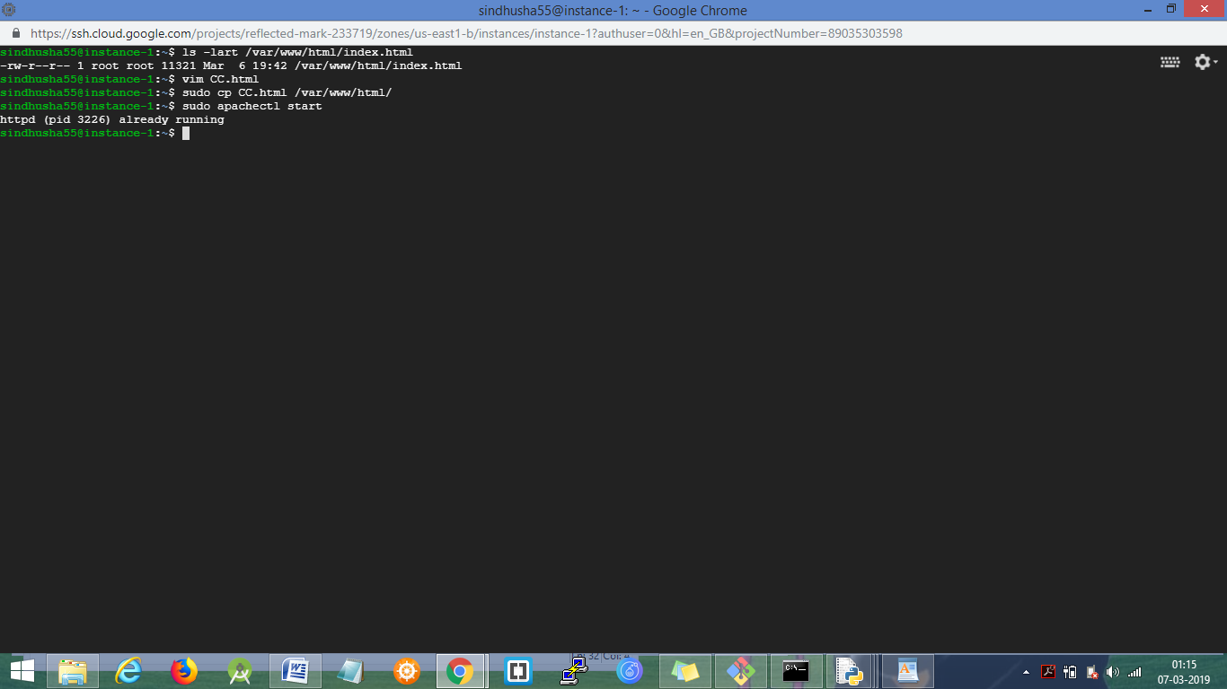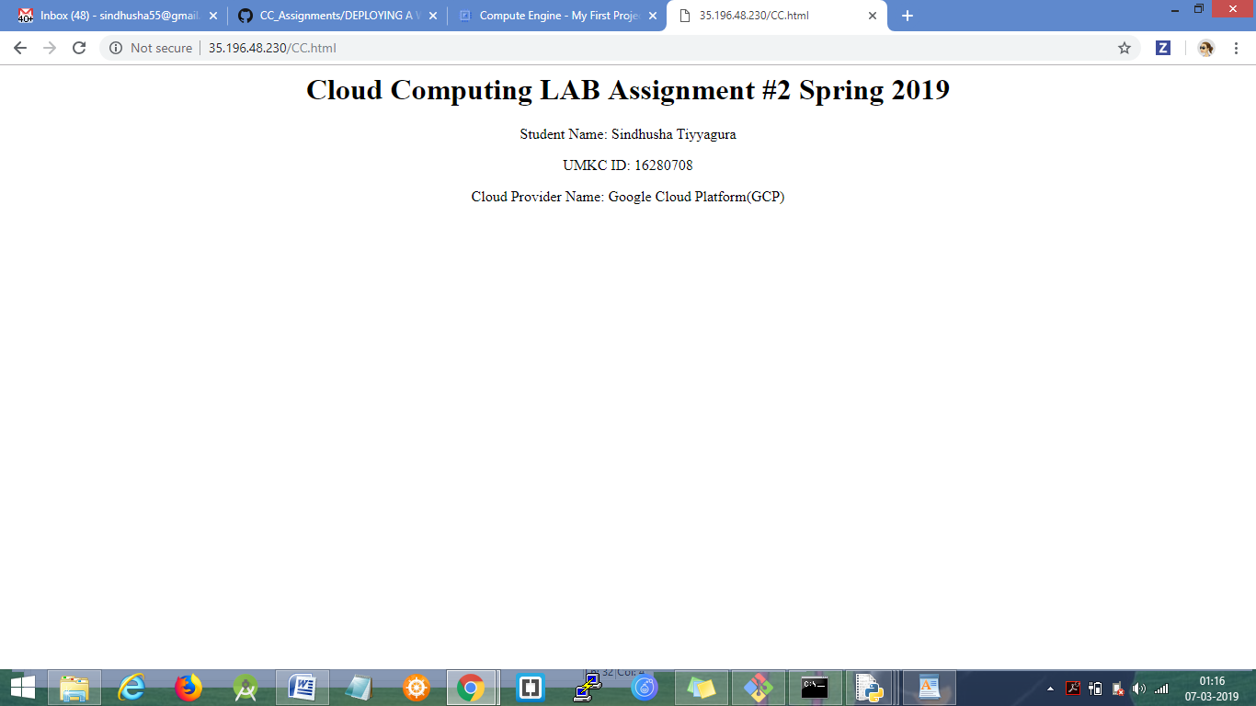

**3) Amazon AWS:**

Created account in Amazon AWS and launched virtual machine instance.

Enabling SSH, HTTP ports for the VM instance.

Starting the VM and connecting to the VM using putty (ssh port – 22)

Executed following commands:

Sudo yum install update

Downloading apache: Sudo yum install apache2

Creating basic html page and storing it in /var/www/html/CC.html

Starting apache port ( httpd daemon) using command sudo apachectl start

Sending HTTP request to the public IP assigned to the Amazon AWS.

IP/CC.html loads the web content on the client web browser.

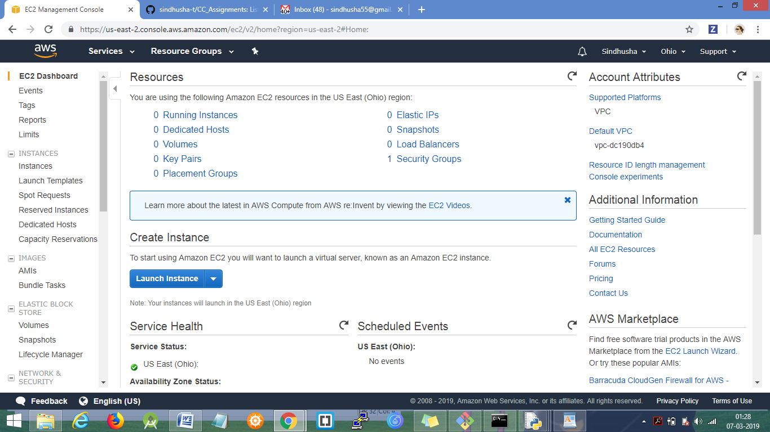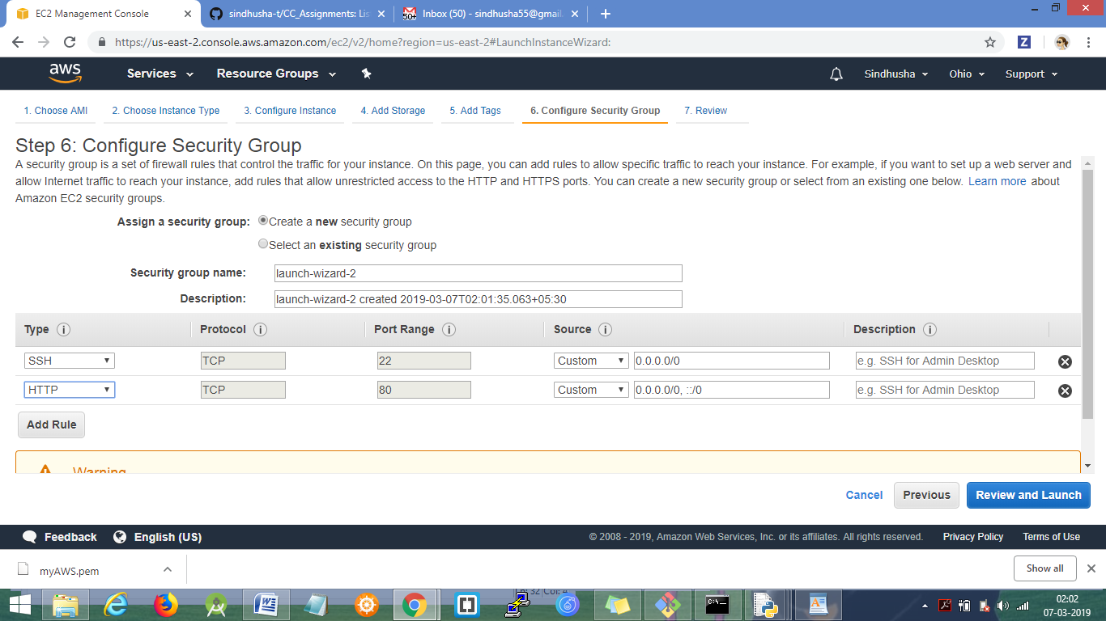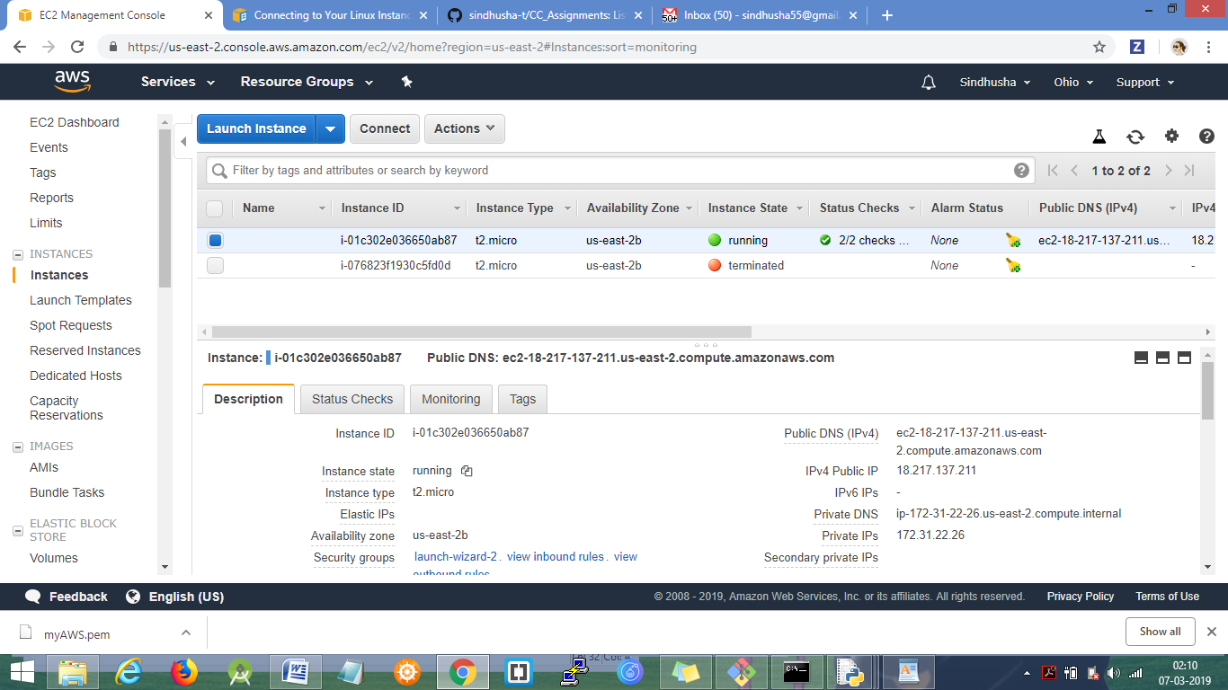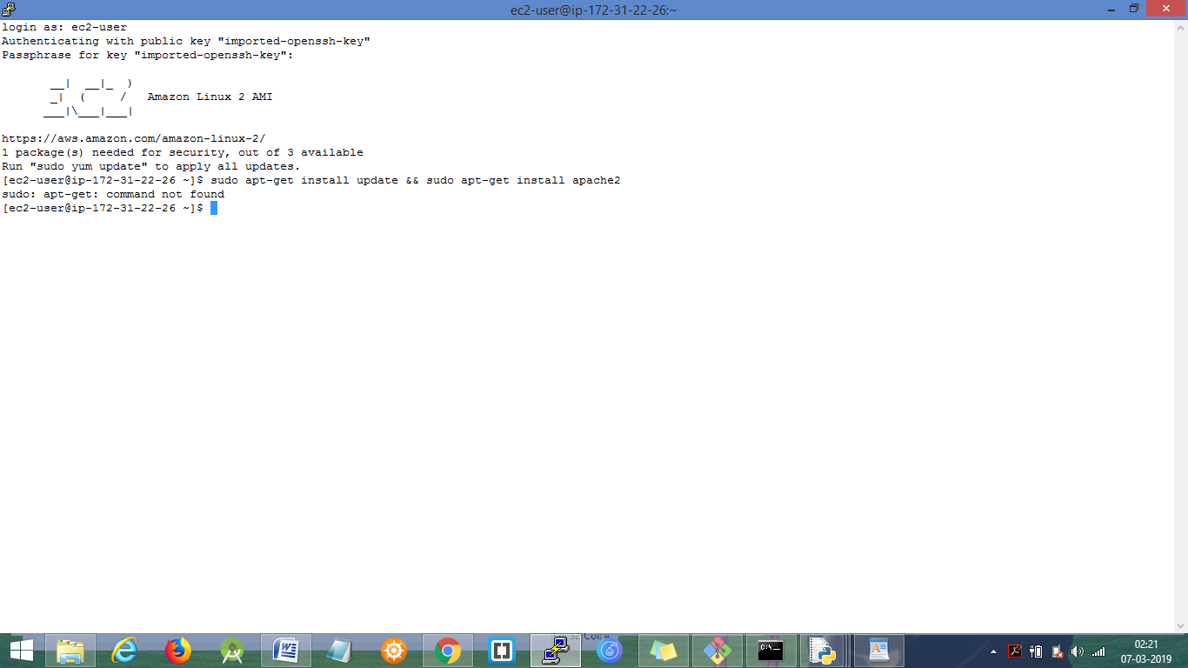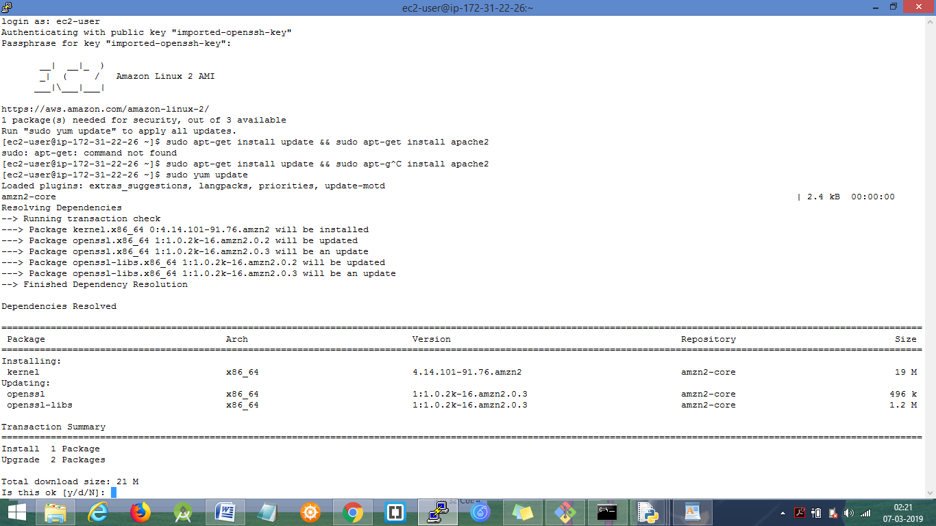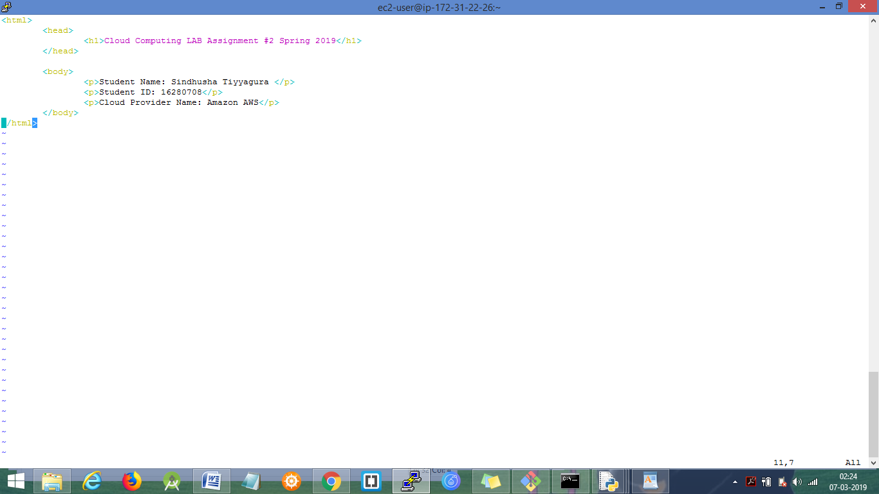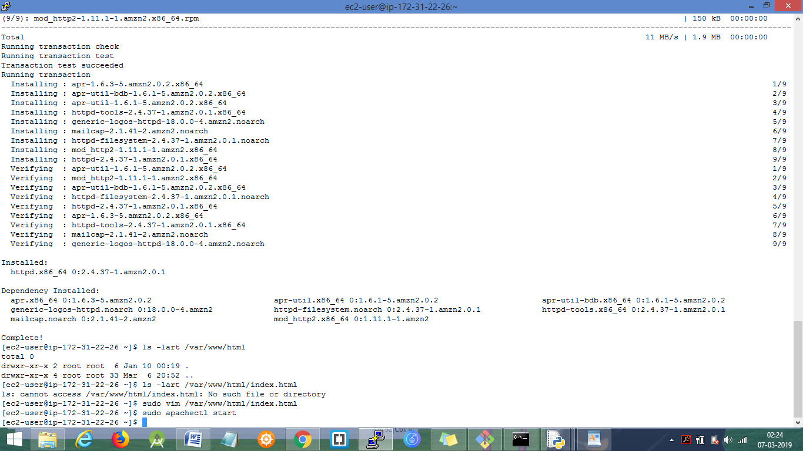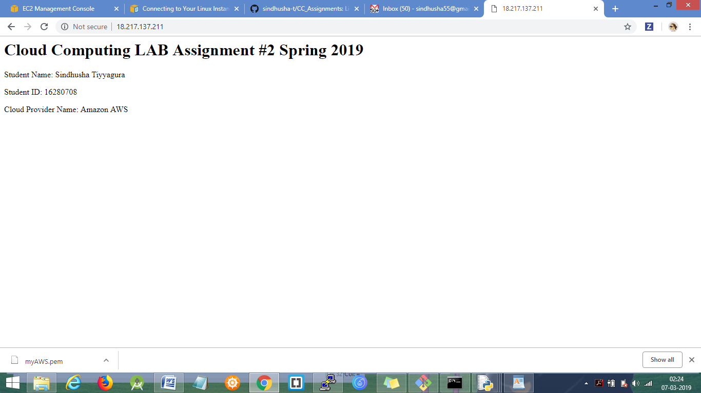

**4) Task-4:**

**a) Lessons Learnt:**

Learnt how to get access to GCP, Azure, AWS public clouds, and how to create and start the VM instance with the required ports being enabled based on our usage.

Learnt few other things related to the 3 public clouds.

**b) Fun/difficult parts:**

1) I enjoyed using the public clouds and deploying a web page on the machines.

2) Initially I forgot to enable the HTTP and SSH ports while creating the instance. So I faced issue in connecting to the server using SSH and also unable to connect to HTTP port for viewing the web page content.

3) Later while doing the same process in other public clouds I was more attentive about the SSH, HTTP ports and the SSH keys while creating the resources.

**c) Comparisons between 3 public clouds used:**

1) Below Cloud providers use the following for the maintaining and managing virtual servers:

AWS uses Elastic Compute Cloud (EC2)

Azure uses virtual machines scale sets

Google cloud platform uses compute engine.

2) AWS is the first one to provide the cloud platform (12 years), next azure (7 years) and then Google (6 years)

3) All three public clouds use pay as you go (on demand pricing model).

AWS prices per hour where as other two like GCP and Azure prices every minute.

4) GCP was introduced after Azure and AWS, but it provides an easy way to connect to the VMs and easily use the resources without any other installations.

5) AWS seems little vague compared to GCP. GCP provides more user friendly user interface.

6) GCP provides few services and few features and contains less data centers.